K – NEAREST NEIGHBORS CLASSIFIER
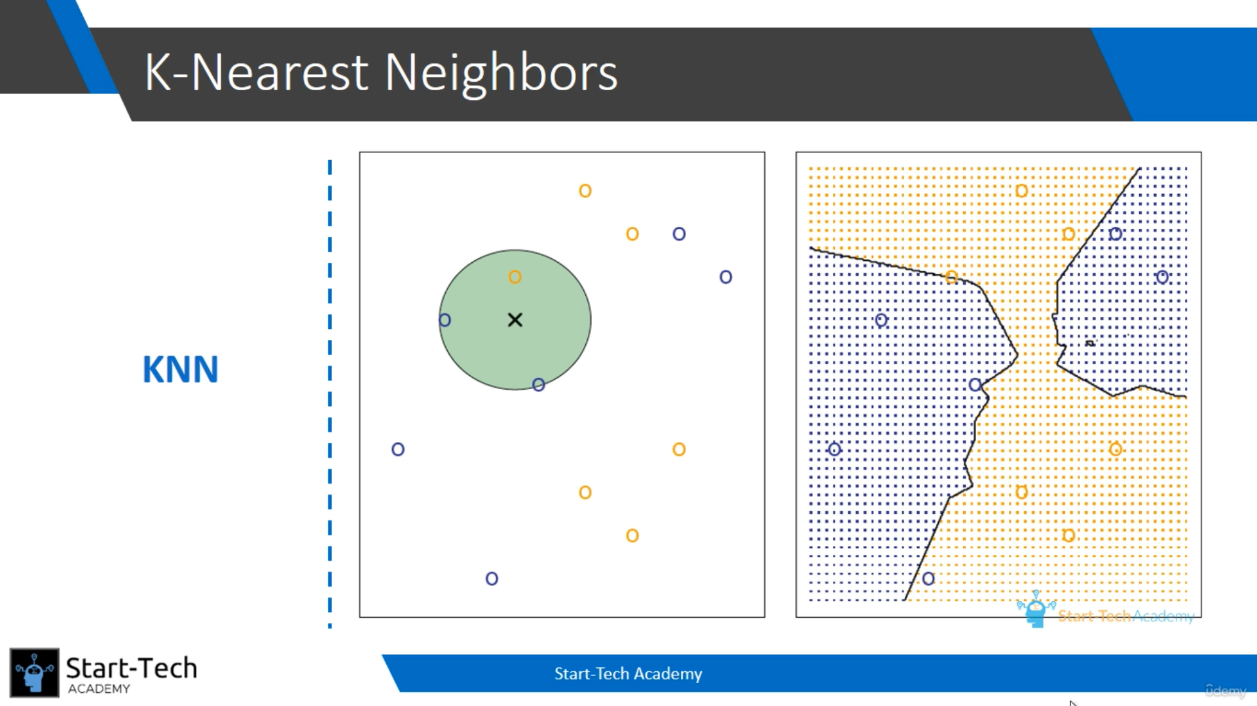
In KNN classifier, we use nearest point to classify the prediction. For example, in the above diagram, the x point will be classified as blue if k = 3, classified as orange if k = 1 and classified randomly if k = 2, because the conditional probability of blue and orange are same if k = 2.
The border line is drawn where the points are changing.
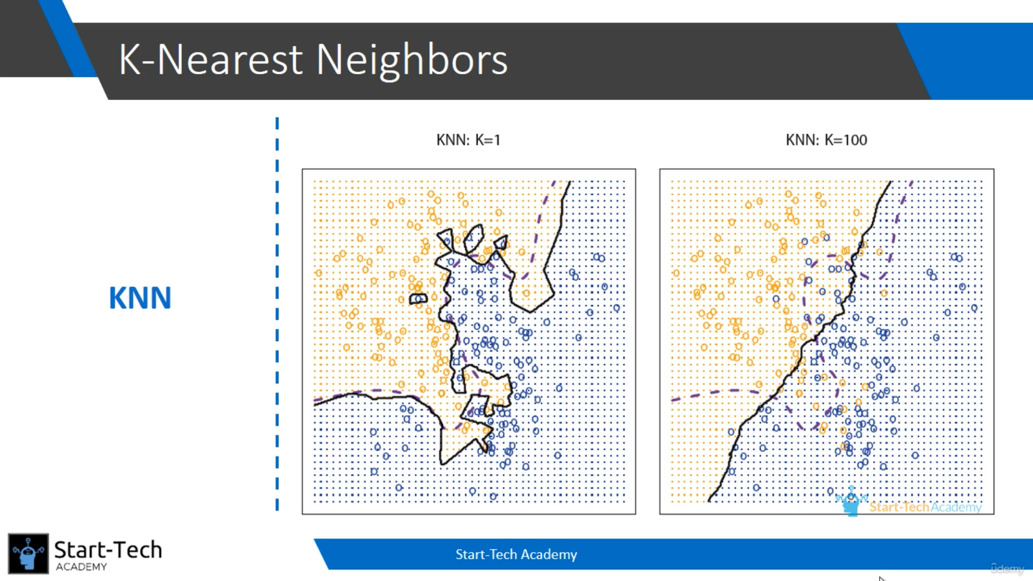
In the above the diagrams, the test error is high. So we need to carefully choose k value to reduce the test error and build a good model.
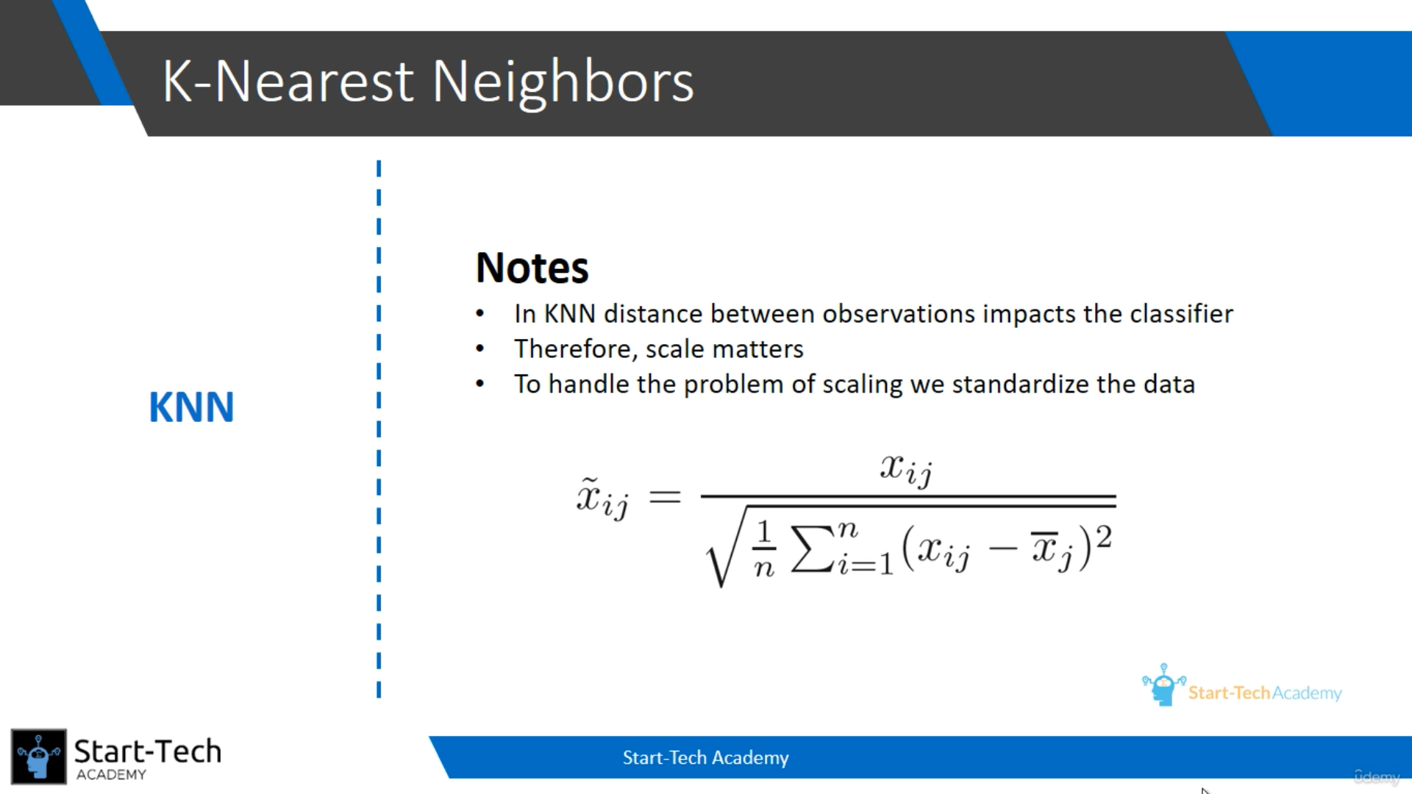
In KNN model, distance impacts the classifier. So, we need to standardize all the variables to get the good model. For eg, salary and age will be have a very high distance, but if we standardize the data, the model will predict properly.

